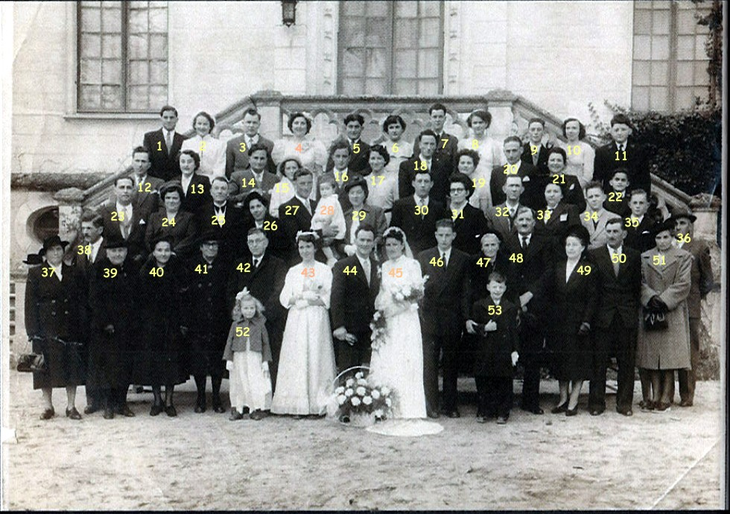
1 |  | 28 | THIBAULT Daniel
2 |  | 29 | CHRISTOPHE Angele
3 | DELALEU Michel | 30
4 | Mme Boissé | 31
5 |  | 32 | CRESPIN Albert
6 |  | 33 | FILLON Madeleine
7 | THIBAULT Guy ( Jules) | 34 | L abbé MarcHAMON
8 |  | 35 | HAMON Jean
9 |  | 36 | GIRAULT Georges ( Papa Georges)
10 |  | 37
11 | ARRAULT André | 38
12 | LAUMONIER Jean | 39
13 | DUBREUIL Christianne | 40 | CARATY LEA
14 | AVENET Lucien | 41
15 | THIBAULT Ghislaine | 42 | Oncle VRILLON Rene
16 | Mr BERGEREAULT | 43
17 | Mme BERGEREAULT | 44 | LAUMONIER Hubert
18 | THIBAULT Michel | 45 | THIBAULT Micheline
19 | LAUMONIER Henriette | 46 | THIBAULT Jean
20 | Mr ROY | 47 | FILLON Fernande
21 | Mme ROY Paulette | 48 | THIBAULT Pierre
22 | ARRAULT Bernard | 49 | Mme DUBREUIL
23 | ARRAULT Pierre | 50 | Mr DUBREUIL
24 | THIBAULT Agnes | 51 | GIRAULT JULIETTE
25 | CARATY Georges | 52 | AVENET Liliane
26 | CARATY Marcelle | 53 | ARRAULT Michel
27 | THIBAULT Maurice | 54

